**Artificial Intelligence and Machine Learning**

**LAB 1**

**Name: PUNEETH L**

**USN: 1BM24MC069**

1. Consider a dataset and perform exploratory data analysis.

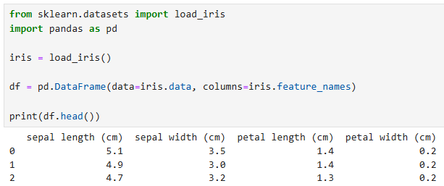

1. Identify the dimension, structure, and summary of the data set

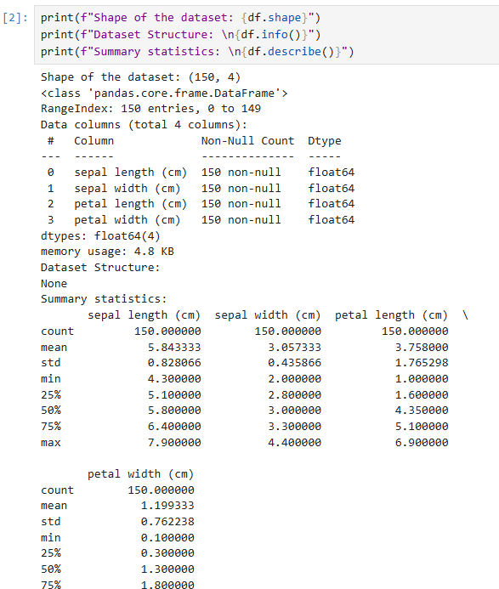

1. Pre-process the dataset and treat them (like missing values, ‘na’?). Justify the treatment.

df = df.fillna(df.mean())

1. Plot the histogram for continuous variables (at least two) to analyse the data.

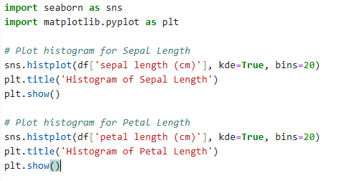

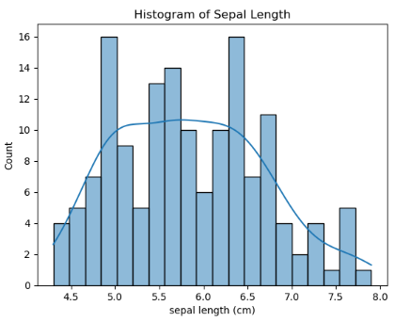

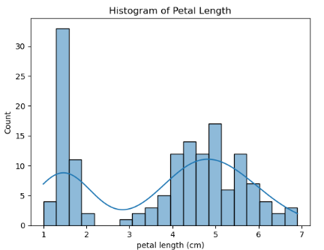

1. Draw a violin plot do describe the distribution of a numerical variable to analyse the data.

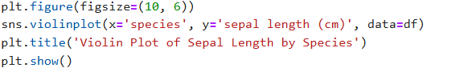

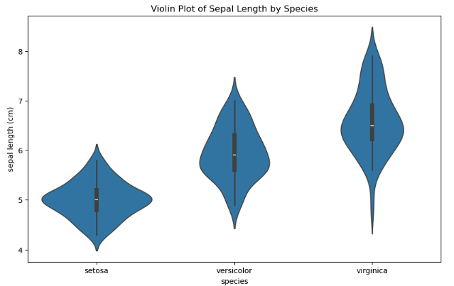

1. Recognize the outliers using box plot (Display the box plot before and after outlier treatment).

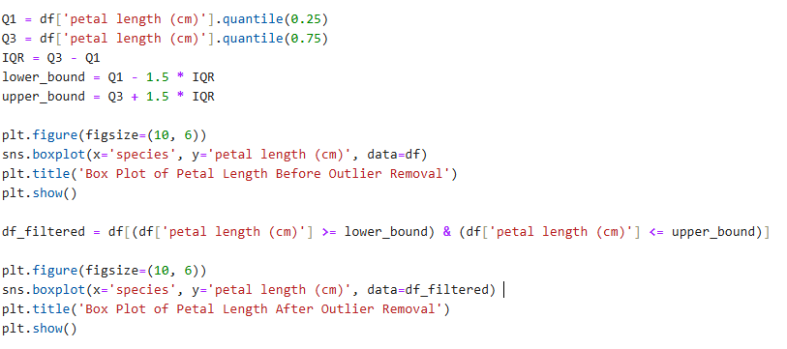

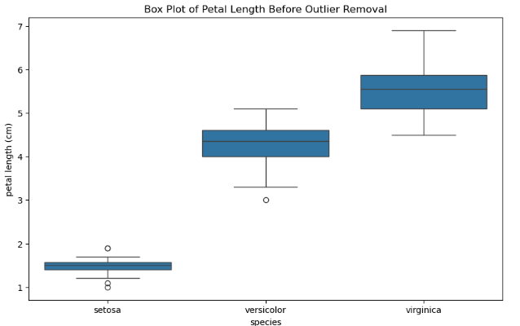 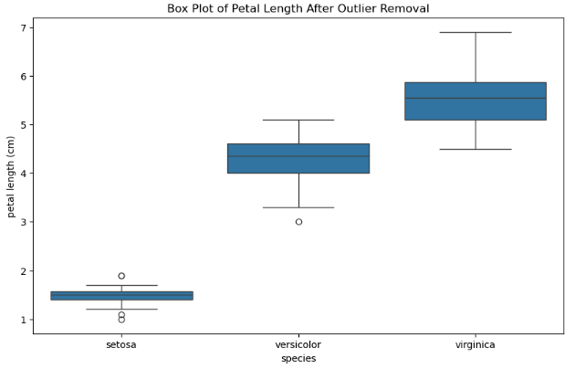

1. Display a heat map to display the relationship among the attributes.

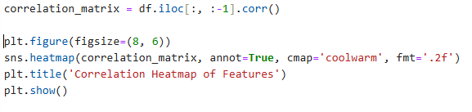

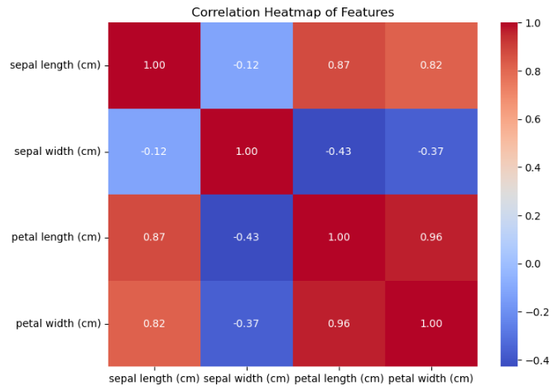

1. Standardize the continuous variable (if any).

